|  |  |  |
| --- | --- | --- |
|  |  | **RANIAATIAMOHAMMED**  **BACKENDDEVELOPER**  **ABOUTME**  **I graduatedfromtheFacultyofSciencewith ahighgrade**  **90.18 %,andI ama teaching assistantin the faculty now**  **OBJECTIVE**  **Self-motivatedandambitious,Iseekchallengingopportunitiewhere Icanfullymyskillsforthesuccessof thecompany**  **SOFTSKILLS**   * **Abilitytoresearchandpublicationforexample:**   1. **Pointof saleweb application.**   2. **Mathematical Modeling of some Differential EquationsUsingNumerical Methods.**   3. **Computationalsolutionoffluidmechanicsproblemsbyusingfiniteelementmethod.** * **Leadership,PatientandPassion.** * **Goodcommunicationskills.** * **Enduranceandworkunderpressure.** * **Experiencewithproblemsolving.**   **TECHNICALSKILLS**   * **DesktopApplicationDeveloperwithc#.** * **DataStructure.** * **AlgorithmandproblemSolving.**   **EXPERIENCE**   * **BACKENDDeveloperATDEXEF.**   **LANGUGES**  **Arabic [Native]English [Advanced]FRENCH[Advanced]** |
|  | **CONTACT** |
| @ | [raniaghonim@gmail.com](mailto:raniaghonim@gmail.com) |
|  | 01113529386 |
|  | **https://github.com/raniaGhoni1998** |
|  | **Monofia,Egypt** |
|  | **EDUCATION** |
|  | **MONOFIAUNIVERSITY**  Bachelor’sdegreeinFacultyofScience.  Mathematics2021  with a gradeof90.18% |

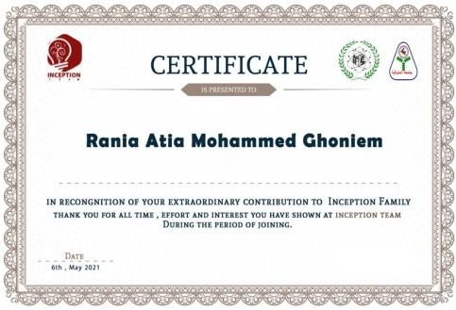CERTIFICATIONS

